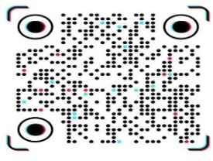

 Penile Doppler Ultrasound Report
Patient Name: Muhammad Bilal Age : 27 years Date: 29/10/2026
Technique:
Baseline (flaccid) and post intracavernosal injection (Papaverine 1ml) evaluation performed.
Findings
________________________________________
Pre-Injection (Flaccid State):

Flow pattern: Low velocity monophasic (PSV = 8 cm/s)
No evidence of plaque/fibrosis/calcification in corpora muscles.

Tunica Albuginea:
• Normal echotexture
• Normal no plaque seen
________________________________________
Post-Injection (Erect State):

Cavernosal arteries: Normal caliber (Right 0.9 mm, Left 0.9mm)
Degree of erection achieved: E3 (Partial erection and rigidity) at 10, 15 minutes.

RIGHT CORPORA CAVERNOSAL ARTERY
Time | PSV (cm/s) | EDV (cm/s) | RI
5 min | 26.60 | 4.5 | 0.83
10 min | 26.50 | 3.4 | 0.87
15 min | 27.80 | 0.0 | 1.00

LEFT CORPORA CAVERNOSAL ARTERY
Time | PSV (cm /s) | EDV (cm/s) | RI
5 min | 28.0 | 4.5 | 0.82
10 min | 27.7 | 3.0 | 0.91
15 min | 25.00 | 0.0 | 1.00

________________________________________

Impression:


- Partial erectile response to intacavernosal injection.
- Normal PSV and EDV on both sides.

Dr. Abdus salam Dr. Sher wali khan Mr. Atta ur rahman
MBBS, FCPS (RADIOLOGY) Consultant Andro urologist MS. Ultrasound

MUHAMMAD MEDICAL COMPLEX PHASE 5 HAYATABAD PESHAWAR
Not valid for legal purpose
03009178101

